Q1) Given the following state for the Banker’s Algorithm.

- 5 processes P₀ through P₄
- 3 resource types A (6 instances), B (9 instances) and C (5 instances).
- Snapshot at time T₀:

 | Max | Allocation
 | A B C | A B C
P₀ | 6 7 3 | 1 1 1
P₁ | 2 2 2 | 1 1 2
P₂ | 2 6 3 | 0 3 0
P₃ | 2 2 2 | 2 1 1
P₄ | 4 6 3 | 1 1 1

- Calculate the available vector.
A Instance-Allocation=6-5=1
B Instance-Allocation=9-7=2
C Instance-Allocation=5-5=0
available
1 2 0
- Calculate the Need matrix

Need=Max-Allocation.

Need
A B C
P₀ | 5 6 2
P₁ | 1 1 0
P₂ | 2 3 3
P₃ | 0 1 1
P₄ | 3 5 2
- Is the system in a safe state? If so, show one sequence of processes which allows the system to complete. If not, explain why. Show your computation step-by-step; otherwise, you will receive no credit.
< P1 P3 P2 P4 P0 >
Work =(1,2,0)+(1,1,2)= (2,3,2 )
Work = (2,3,2)+ (2,1,1)= (4,4,3)
Work = (4,4,3 ) +(0 ,3 ,0)= (4,7,3)
Work = (4,7,3) +(1,1,1)= (5,8,4)
Work = (5,8,4) +(1,1,1)= (6,9,5)

Yes,system in a safe state

d) Given the request (1, 2, 0) from Process P₂. Should this request be granted? Why or why not? Show your computation step-by-step; otherwise, you will receive no credit.

Req(1,2 ,0)<= need(2 3 3)
Req(1,2 ,0)<=ava(1,2,0)
Available=( 1,2,0) - (1,2,0)=(0,0,0)
Allocation= ( 0 ,3, 0) +(1 ,2, 0)=(1,5, 0)
Need =(2,3,3)- (1,2, 0)=(1,1,3)

the new state after the allocation is
 | Max | Allocation | Need  A B C | Available
 | A B C | A B C | A B C | 0,0,0
P₀ | 6 7 3 | 1 1 1 | 5 6 2
P₁ | 2 2 2 | 1 1 2 | 1 1 0
P₂ | 2 6 3 | 1 5 0 | 1 1 3
P₃ | 2 2 2 | 2 1 1 | 0 1 1
P₄ | 4 6 3 | 1 1 1 | 3 5 2

No, this request can not be granted

Q2) A system has three processes (P₁, P₂, P₃) and three reusable resources (R₁, R₂, R₃). There is one instance of R₁, two instances of R₂ and three instances of R₃. P₁ holds an R₁ and an R₃ and is requesting an R₂. P₂ holds an R₃ and is requesting an R₁ and an R₂. P₃ holds two R₂ and an R₃ and is requesting an R₁.

a) Draw the resource allocation graph for this situation.

- Write all the cycle(s) in the graph.
P3 R1 P1 R2 P3

c) Does a deadlock exist? Why?
YES ,
- Mutual exclusion condition applies
- Hold-and-wait condition applies
- No-preemptive condition applies
- Circular wait condition applies

Q3)

a. Increase Available (new resources added)—This could safely be changed without any problems.

b. Decrease Available (resource permanently removed from system)—This could have an effect on the system and introduce the possibility of deadlock as the safety of the system assumed there were
a certain number of available resources.

c. Increase Max for one process (the process needs more resources than allowed, it may want more)—This could have an effect on the system and introduce the possibility of deadlock.

d. Decrease Max for one process (the process decides it does not need that many resources)—This could safely be changed without any problems.

e. Increase the number of processes—This could be allowed assuming that resources were allocated to the new process(es) such that the system does not enter an unsafe state.

f. Decrease the number of processes—This could safely be changed without any problems.

Traffic deadlock example
Consider the traffic deadlock represented in the following figure
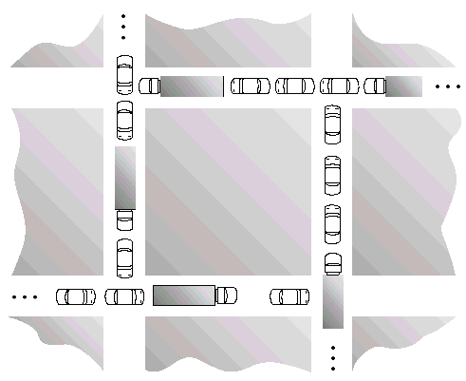
- Show that the 4 necessary conditions for deadlock indeed hold in this example
Consider each section of the street as a resource.
- Mutual exclusion condition applies, since only one vehicle can be on a section of the street at a time.
- Hold-and-wait condition applies, since each vehicle is occupying a section of the street, and waiting to move on to the next section of the street.
- No-preemptive condition applies, since a section of the street that is a section of the street that is occupied by a vehicle cannot be taken away from it.
- Circular wait condition applies, since each vehicle is waiting for the next vehicle in front of it to move.

- State a simple rule that will avoid deadlocks in the system

The simple rule to avoid traffic deadlock is that a vehicle should only enter an intersection if it is assured that it will not have to stop inside the intersection.

